**Fazaa Online System: Automating the mundane tasks related to volunteering in the school**

By:

Hamza Ahmed

Eisa Ahmed

Yaaqoub Al Houqani

Under the supervision of:

Mr. Nathaniel Haswell

Revised: June/2020

Table of Contents

*Abstract* 3

*Introduction* 4

*Background and Reasoning* 4

*Hypothesis* 4

*Objectives* 4

*Existing sloutions* 5

*Alternative applications* 5

*Future trends* 5

*Benefits* 5

***General benefits*** 5

***Environmental benefits*** 6

*Technologies* 6

**Firebase** 6

**Firebase Cloud Firestore** 6

**Bootstrap** 7

**JavaScript** 7

**HTML** 7

**CSS** 7

*Conclusion* 7

*References* 8

# **Abstract**

All students under ACTVET schools must complete a number of volunteering hours before graduating. As a result of a missing system for Fazaa [1], students have to go through lengthy processes to just check the available volunteering events or check the amount of volunteering hours that they have done which places pressure on the counselor of the school. We created an online system that is capable of storing the Fazaa information of students and giving them the ability to track this information and allowing them to register for volunteering opportunities, while also reducing the workload on the counselor allowing him to organize more volunteering opportunities.

# **Introduction**

At our school, students are required to do 100 hours of volunteering [2]. Unfortunately, registering for volunteering and checking the number of hours completed is a manual process. The duty of managing the database that contains the Fazaa information of students and informing students about volunteering opportunities. To confirm volunteering, students must fill a paper form and get it approved from a supervisor before their hours can be added. To check the volunteering progress or volunteering chances, the student must visit the counsellor and ask him, but this is very inefficient, and the counsellor could be busy. Our project is called **Fazaa Online System**, which is an online platform aiming to automate the mundane tasks related to volunteering in the school, both on the students and the administration side of the matter.

**Fazaa** [1] is the name of the volunteering program at our school system. [2]

# **Background and Reasoning**

In the long term, Fazaa Online System will help both students and counselors and supervisors.

* Students go through lengthy processes which can be automated.
* Pressure on the counselor because a lot of students are requesting information.
* Our system can automate a lot of things which can be automated.
* More students register for volunteering because it is done through a website with all available opportunities listed.
* Counselors have more time to organize more volunteering opportunities

# **Hypothesis**

Time is wasted when students have to visit the counselor to check the number of hours they have volunteered and get an update on the available volunteering opportunities, and the counselor gets overwhelmed with 20 students wanting to check at once. The system will be able to provide convenience to both students and administartion.

# ***Objectives***

* To allow students to access their Fazaa information without a hassle.
* To permit students to know what kind of activities they can volunteer in, and we want them to be able to volunteer without having to meet several supervisors.
* To enable students to view their volunteering history and their number of completed hours.
* To reduce the amount of papers wasted and the cost of the printing, copying, and distribution of the paper forms used. [3].
* To allow thre administration to reliably and efficiently access and retrieve the school student's progress at any given time from anywhere with an internet connection.

# **Existing sloutions**

The school currently follows a paper-based and oral system of announcing volunteering opportunities, registering students, collecting hand-written student forms and manual validation, and data entry of each student’s volunteering session.

# **Alternative applications**

This technology can be used to support any system that wants to reduce the number of mundane tasks and paperwork required to track and record people’s progress in something and be able to support fast and reliable retrieval of the data, essentially digital transformation and automation [4].

For example, a system that replaces the need for nurses to track and sign a patient’s medication progress sheet, where the patient can input their medication intake daily into the system, and the supervising nurse can approve and verify their progress from their side of the system.

Or a system that allows parents to create certain activities for their kids, in which their kids can be informed about the activities that their parents had set up, and then get rewarded once completed within the specified period, such system might adopt a point system that allows the kids to redeem their points for goods or candy etcetera. The parents would be able to track their children’s progress at any given time.

# **Future trends**

Future paths for such an idea may include the expansion to and inclusion of other schools in the country which are adopting a similar volunteering aspect in their systems. [2] And ones who face identical trends of the lack of data access and centralization; due to old fashioned paperwork and unorganized data sets.

It might expand to provide digital transformation to SMEs who might require a digitization of their forms and task-tracking procedures [5].

# **Benefits**

## **General benefits**

This system automates such manual practices of tracking recording something’s or someone’s progress e.g. volunteering.

This technology allows administrative staff, faculty, and the supervision team to reliably and efficiently access and retrieve the system user's progress at any given time from anywhere with an internet connection. The system centralizes the data in a way that reduces data redundancy and inconsistency that can exist as a result of the existence of multiple copies of the same spreadsheet or database that are locally stored on multiple devices which in return enhances and improves the reliability and integrity of the data [6].

It also notifies the users about ongoing or upcoming tasks or activities.

## **Environmental benefits**

Our project affects society and the environment positively since more people (students) are willing to volunteer. For example, schools could partner up with local organizations that aim to improve the local nature and environment and setup volunteering opportunities that students could volunteer in, this would benefit such organizations a lot.

It also helps with reducing the carbon footprint and saving trees, being a paperless system [3] that replaces paper-based systems, which in turn reduces or eliminates the use of paper, making it an environment-friendly technology [7]

# **Technologies**

### **Firebase**

This is a development platform that will handle the authentication, database and storage of the website. The website will also be hosted and served from Firebase. Firebase allows authentication using many different providers, it can be done using an email and a password or using a phone number or one of the supported providers such as Google, Microsoft, Facebook or Github. [8]

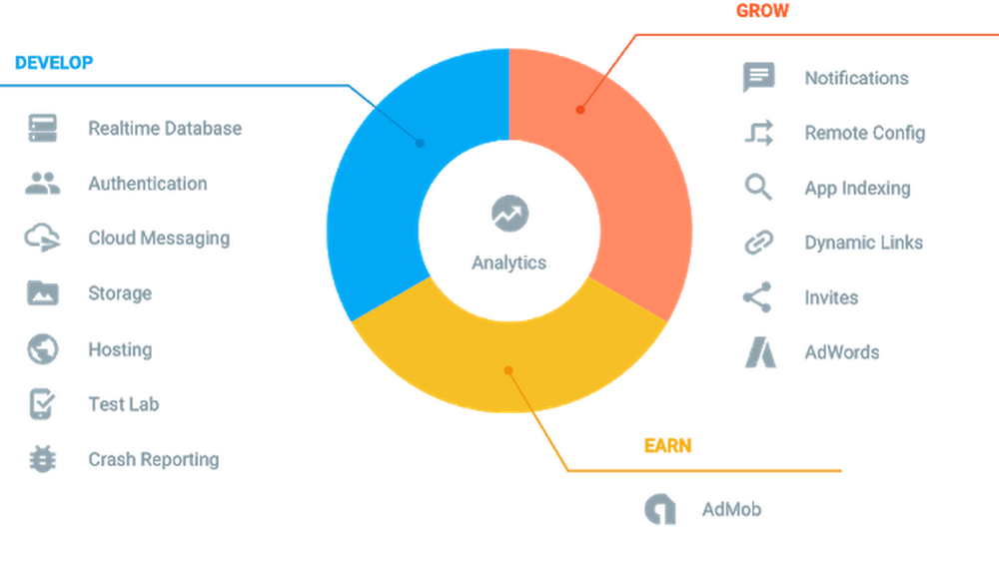

*Features of Firebase.*

### **Firebase Cloud Firestore**

Firebase has two databases that can be used with projects, Firebase Realtime Database and Firebase Cloud Firestore [9] For our project, we chose Firebase Cloud Firestore because it is newer than Firebase Realtime Database and it is less complex when it comes to the way data is organized within the database. Running queries in Cloud FIrestore allows us to freely sort and filter in a single query while Realtime Database can only sort or filter in each query.

### **Bootstrap**

Bootstrap is a front-end framework for building websites easily and quickly. It provides the developer with HTML and CSS based design templates for different things such as forms, buttons, tables and navigation. It also simplifies the development of a website that is usable on multiple types of devices. [10]

### **JavaScript**

This programming language is used to program web pages allowing them to be more dynamic, things like animations, content updates and interactive maps are all implemented using JavaScript. [11] In our project, JavaScript is used to interact with Firebase.

### **HTML**

HTML (Hypertext Markup Language) is used to place all the content in a web page (text, images, buttons etc). It is used to structure a web page and inform the browser on how the elements are displayed. [12]

### **CSS**

Cascading Style Sheets is used to create great looking pages by modifying the visual properties of an HTML element. It is possible to use it for basic text styling such as changing the color of a heading element or for advanced styling such as creating a layout. [13]

# 

# **Conclusion**

By creating this system, we save students the hassle of having to contact the counselor to view their progress and check for new volunteering chances. This will

encourage more students to volunteer.

# **References**

|  |  |
| --- | --- |
| [1] | Fazaa, "Actvet," [Online]. Available: https://www.actvet.gov.ae/en/Initiatives/Pages/Fazaa.aspx. |
| [2] | MOE, "UAE School Volunteering Principles," [Online]. Available: https://www.moe.gov.ae/En/ImportantLinks/Skills/Volunteering/Pages/Principles.aspx. |
| [3] | D. Kempner, "Ten Benefits of Going Paperless," 07 July 2014. [Online]. Available: https://community.aiim.org/blogs/dennis-kempner/2014/07/29/ten-benefits-of-going-paperless. |
| [4] | C. Matt, T. Hess and A. Benlian, "Digital Transformation Strategies," *Business & Information Systems Engineering,* pp. 339-343, 2015. |
| [5] | "Why should SMEs go digital?," 16 January 2020. [Online]. Available: https://www.straitstimes.com/business/why-should-smes-go-digital. |
| [6] | G. Sivathanu, C. P. Wright and E. Zadok, "Ensuring Data Integrity in Storage: Techniques and Applications," in *Proceedings of the 2005 ACM workshop on Storage security and survivability*, pp. 26-36. |
| [7] | Mushhad, S. M. Gilani, J. Ahmed and M. A. Abbas, "Electronic document management: a paperless university model," in *2009 2nd IEEE International Conference on Computer Science and Information Technology*, 2009, pp. 440-444. |
| [8] | C. Esplin, "What is Firebase?," 24 October 2016. [Online]. Available: https://howtofirebase.com/what-is-firebase-fcb8614ba442. |
| [9] | Firebase, "Firebase documentation," 02 March 2020. [Online]. Available: https://firebase.google.com/docs/firestore.. |
| [10] | T. Rascia., "What is Bootstrap and How Do I Use It?," 10 November 2015. [Online]. Available: https://www.taniarascia.com/what-is-bootstrap-and-how-do-i-use-it/. |
| [11] | A. Grant., "What Is JavaScript and How Does It Work?," 06 December 2016. [Online]. Available: https://www.makeuseof.com/tag/what-is-javascript/. |
| [12] | C. Hope, "H - Definitions," 13 November 2018. [Online]. Available: https://www.computerhope.com/jargon/h/html.htm.. |
| [13] | C. Hope, ""CSS.” C - Definitions," 16 November 2019. [Online]. Available: https://www.computerhope.com/jargon/c/css.htm. |